VERIFICATION DETAILS

NAME OF THE REGION: | EASTERN REGION
SUB-REGION: | KAMULI
Name of Local Government | KAMULI DISTRICT
VERIFIER PARTICULARS
Full name | NAMUGANGA SHARYPHA
Contact/ email and Telephone | 0782 619901
Supervisor/ Sub team leader
Name

Contact
Date of submission

HEALTH CENTRES
INFORMANT INTERVIEW/DISCUSSION GUIDE (INCHARGE OR RESPONSIBLE PERSON)

Name of Health Centre: Bubago Health Center III

1a | Does the Facility have a record of all assets provided under UgIFT?  (Obtain a record and verify if it has the costs and numbers supplied | Record has only quantity and no costs
1b | If Not ask how many were supplied and when.

2 | How does this facility Maintain (repair/service/replace) the assets provided under Ugift

3 | Does the facility take regular record about functionality/ or breakdown of the assets provided? | No

4 | How has the UgIFT support helped in service delivery in the area, any issues, challenges and any recommendations for better program implementation.

PROCEED TO VERIFICATION AFTER THIS DISCUSSION

Health centre checklist

NAME OF LG……Kamuli District…………………………………… NAME OF HEALTH FACILITY…………Bubago HC III………………………………………………

Equipment/ Item | Department | Asset Number | Item  Description | Life in Months | Tag Number ( engrave no.) | Date Of Purchase | Date Placed In Service | Recoverable cost | Cost | Acc Dep Cost | Net Book Value | Ytd Deprn | Equipment status | Remarks
B.P. Machine, Digital | Health |  |  |  | Bubago HC III |  | 21/09/2022 |  |  |  |  |  | Functional | Received 2
B.P. Machine (Aneroid wall mounted) | Health |  |  |  | Bubago HC III |  | 21/09/2022 |  |  |  |  |  | Functional | Received 2
Autoclave 20 Liters.,Duo Operated | Health |  |  |  | Bubago HC III |  | 21/09/2022 |  |  |  |  |  | Functional | Received 2
Bowl, Kick | Health |  |  |  | Bubago HC III |  | 21/09/2022 |  |  |  |  |  | Functional | Received 1
Bowl Stand | Health |  |  |  | Bubago HC III |  | 21/09/2022 |  |  |  |  |  | All rusty | Received 3
Counting chamber Neubauer- Improved
Cupboard Steel, Lockable | Health |  |  |  | Bubago HC III |  | 21/09/2022 |  |  |  |  |  |  | Received 6
Drip Stand | Health |  |  |  | Bubago HC III |  | 21/09/2022 |  |  |  |  |  |  | Received 9
ESR Stand | Health |  |  |  | Bubago HC III |  | 21/09/2022 |  |  |  |  |  |  | Received 1
Examination Couch | Health |  |  |  | Bubago HC III |  | 21/09/2022 |  |  |  |  |  |  | Received 4
Examination light,LED
Glucometer
Haemoglobin Meter, Digital
Height Meter | Health |  |  |  | Bubago HC III |  | 21/09/2022 |  |  |  |  |  | All broken down | Received 2
Instrument Trolley | Health |  |  |  | Bubago HC III |  | 21/09/2022 |  |  |  |  |  | Functional | Received 4
Microscope Binocular
Otoscope | Health |  |  |  | Bubago HC III |  | 21/09/2022 |  |  |  |  |  | Functional | Received 1
Patient Screen | Health |  |  |  | Bubago HC III |  | 21/09/2022 |  |  |  |  |  | 4 broke down on delivery | Received 5
Patient Trolley | Health |  |  |  | Bubago HC III |  | 21/09/2022 |  |  |  |  |  | Functional | Received 1
Refrigerator, Basic | Health |  |  |  | Bubago HC III |  | 21/09/2022 |  |  |  |  |  | Functional | Received 2
Stethoscope | Health |  |  |  | Bubago HC III |  | 21/09/2022 |  |  |  |  |  | Functional | Received 8
Stop Watch | Health |  |  |  | Bubago HC III |  | 21/09/2022 |  |  |  |  |  | Functional | Received 1
Stretcher | Health |  |  |  | Bubago HC III |  | 21/09/2022 |  |  |  |  |  | Functional | Received 2
Stove, Gas | Health |  |  |  | Bubago HC III |  | 21/09/2022 |  |  |  |  |  |  | The stove is not in use because there no gas was provided
Weighing Scale with Height Meter, Adult | Health |  |  |  | Bubago HC III |  | 21/09/2022 |  |  |  |  |  | Broke down | Received 2. Equipment wasn’t used as it was already not functioning on delivery
Weighing Scale, Infant | Health |  |  |  | Bubago HC III |  | 21/09/2022 |  |  |  |  |  | Functional | Received 2
Weighing Scale, Toddler | Health |  |  |  | Bubago HC III |  | 21/09/2022 |  |  |  |  |  | Functional | Received 2
Wheel Chair | Health |  |  |  | Bubago HC III |  | 21/09/2022 |  |  |  |  |  | Functional | Received 4
Audio Visual Equipment
Medical Waste Bin | Health |  |  |  | Bubago HC III |  | 21/09/2022 |  |  |  |  |  | Functional | Received 10
Wall Clock | Health |  |  |  | Bubago HC III |  | 21/09/2022 |  |  |  |  |  | Functional | Received 4
Diagnostic Equipment Set for MCH | Health |  |  |  | Bubago HC III |  | 21/09/2022 |  |  |  |  |  | Functional | Received 3
Diagnostic Equipment Set for OPD | Health |  |  |  | Bubago HC III |  | 21/09/2022 |  |  |  |  |  | Functional | Received 2
Glassware Set, Laboratory, Basic | Health |  |  |  | Bubago HC III |  | 21/09/2022 |  |  |  |  |  | Functional | Received 2
Hollow Ware Set, Treatment | Health |  |  |  | Bubago HC III |  | 21/09/2022 |  |  |  |  |  | Functional | Received 2
Instrument Set, Dressing | Health |  |  |  | Bubago HC III |  | 21/09/2022 |  |  |  |  |  | Functional | Received 2
Instrument Set, Basic ENT | Health |  |  |  | Bubago HC III |  | 21/09/2022 |  |  |  |  |  | Functional | Received 1
Instrument Set, Suture | Health |  |  |  | Bubago HC III |  | 21/09/2022 |  |  |  |  |  | Functional | Received 3
Pulse Oximeter, Hand held | Health |  |  |  | Bubago HC III |  | 21/09/2022 |  |  |  |  |  | Functional | Received 2
Bed, Adult Patient with Mattress | Health |  |  |  | Bubago HC III |  | 21/09/2022 |  |  |  |  |  | Functional | Received 10 adult patient beds and mattresses
Bed, Pediatric Patient, With Mattress | Health |  |  |  | Bubago HC III |  | 21/09/2022 |  |  |  |  |  | Functional | Received 4 pediatric patient beds with mattresses
Bedside Locker
Cupboard, Instrument | Health |  |  |  | Bubago HC III |  | 21/09/2022 |  |  |  |  |  | Functional | Received 1
Delivery Bed, Hydraulic Manual
Oxygen Therapy Apparatus, Mininum 45L cylinder
Resuscitator Manual, Infant, with all Mask sizes | Health |  |  |  | Bubago HC III |  | 21/09/2022 |  |  |  |  |  |  | Received 1. Equipment still in store
Resuscitator Manual, Adult, with all mask sizes | Health |  |  |  | Bubago HC III |  | 21/09/2022 |  |  |  |  |  | Functional | Received 1. Equipment still in store
Suction Apparatus, (Electric) | Health |  |  |  | Bubago HC III |  | 21/09/2022 |  |  |  |  |  | Functional | Received 1.
Nebulizer, Ultrasonic | Health |  |  |  | Bubago HC III |  | 21/09/2022 |  |  |  |  |  | Functional | Received 1.
Oxygen Concentrator, Duo Flow | Health |  |  |  | Bubago HC III |  | 21/09/2022 |  |  |  |  |  | Not operational | Received 1. Staff were not trained to use the equipment.
Bench | Health |  |  |  | Bubago HC III |  | 21/09/2022 |  |  |  |  |  | Functional | Received 4.
Disinfection Buckets | Health |  |  |  | Bubago HC III |  | 21/09/2022 |  |  |  |  |  | Functional | Received 6.
Baby Cot | Health |  |  |  | Bubago HC III |  | 21/09/2022 |  |  |  |  |  | Functional | Received 2
Diagnostic Equipment Set for Ward | Health |  |  |  | Bubago HC III |  | 21/09/2022 |  |  |  |  |  | Functional | Received 2
Hollow Ware Set, Ward | Health |  |  |  | Bubago HC III |  | 21/09/2022 |  |  |  |  |  | Functional | Received 2
Instrument Set, Delivery | Health |  |  |  | Bubago HC III |  | 21/09/2022 |  |  |  |  |  | Functional | Received 5
Instrument Set, Stitch Removing | Health |  |  |  | Bubago HC III |  | 21/09/2022 |  |  |  |  |  | Functional | Received 5
MVA Kit | Health |  |  |  | Bubago HC III |  | 21/09/2022 |  |  |  |  |  | Functional | Received 5
Stool, Laboratory | Health |  |  |  | Bubago HC III |  | 21/09/2022 |  |  |  |  |  | Functional | Received 4
Penguin Sucker | Health |  |  |  | Bubago HC III |  | 21/09/2022 |  |  |  |  |  | Functional | Received 3
Fetoscope, Dopplar | Health |  |  |  | Bubago HC III |  | 21/09/2022 |  |  |  |  |  | Functional | Received 2
Bubble CPAP
Centrifuge (Electric) | Health |  |  |  | Bubago HC III |  | 21/09/2022 |  |  |  |  |  | Functional | Received 1
Kangaroo Mother Care Chair | Health |  |  |  | Bubago HC III |  | 21/09/2022 |  |  |  |  |  | Functional | Received 1
Radiant Infant Warmer
Haemoglobin Meter, Sahli
Delivery Bed | Health |  |  |  | Bubago HC III |  | 21/09/2022 |  |  |  |  |  | Functional | Received 1
Examination light
Instrument set, ENT Basic for HCIII
Bag Valve mask (Ambu Bag), Neonatal | Health |  |  |  | Bubago HC III |  | 21/09/2022 |  |  |  |  |  | Functional | Received 15
Incubator
Office Chair | Health |  |  |  | Bubago HC III |  | 21/09/2022 |  |  |  |  |  | Functional | Received 5
Desk | Health |  |  |  | Bubago HC III |  | 21/09/2022 |  |  |  |  |  | Functional | Received 7
Filing Cabinet | Health |  |  |  | Bubago HC III |  | 21/09/2022 |  |  |  |  |  | Functional | Received 6
Non Residential Buildings
Residential Buildings

Bubago HC III: Key Challenges and Recommendations
Challenges
- Inadequate lighting: 8 ceiling light fittings are non-functional and costly to replace, resulting in inadequate lighting in affected rooms particularly at night.
- Equipment failure: The solar inverter, weighing scale, TV screen, and blood pressure machines supplied to the facility have broken down, limiting their functionality
- Limited equipment capacity: The oxygen concentrator is currently non-functional due to inadequate staff capacity to operate and maintain the equipment.
Recommendations
- Provision of essential medical and safety equipment: UGiFT should support the facility with an ultrasound machine, CBC analyzer, chemistry analyzer, suction machine, fire extinguishers, incinerator, and appropriately sized waste bins to strengthen diagnostic, emergency, infection-prevention, and waste-management services.
- Solar power for staff quarters: Provide a solar power system for the staff quarters to improve reliable access to electricity.
- Equipment operation and maintenance: Provide user training and basic maintenance support to health workers on the operation and management of specialized equipment, particularly the oxygen concentrator.

No | Asset description | Photo asset
1 | The entire facility building that houses all departments. | 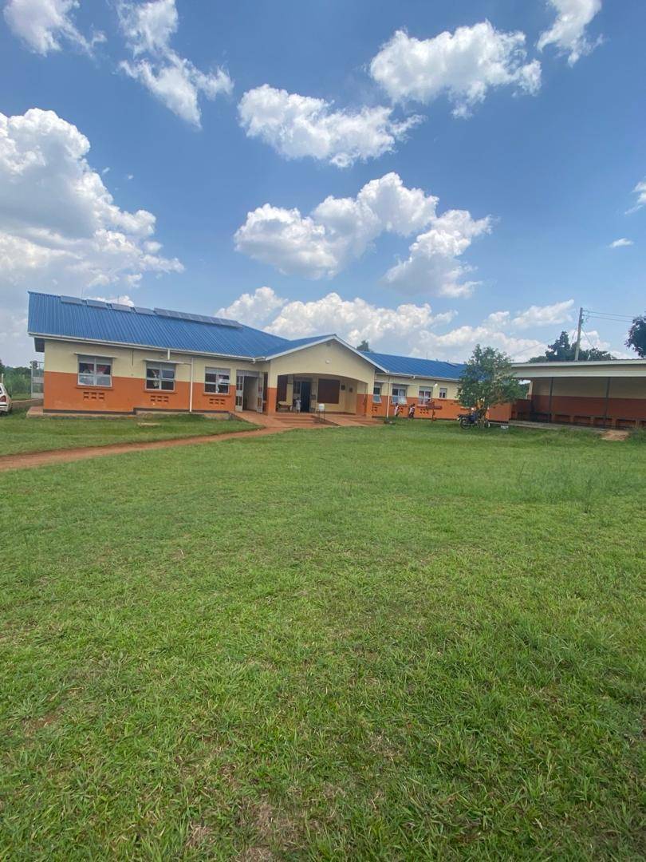
2 | The patient waiting area at the facility. | 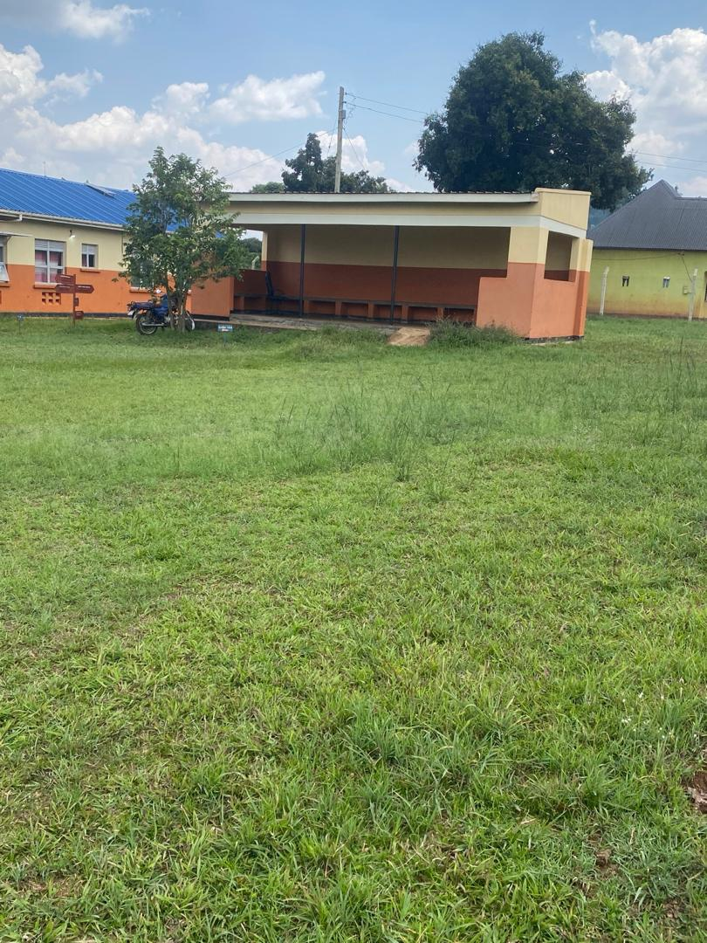
3 | The male and female VIP latrines (4 stance) | 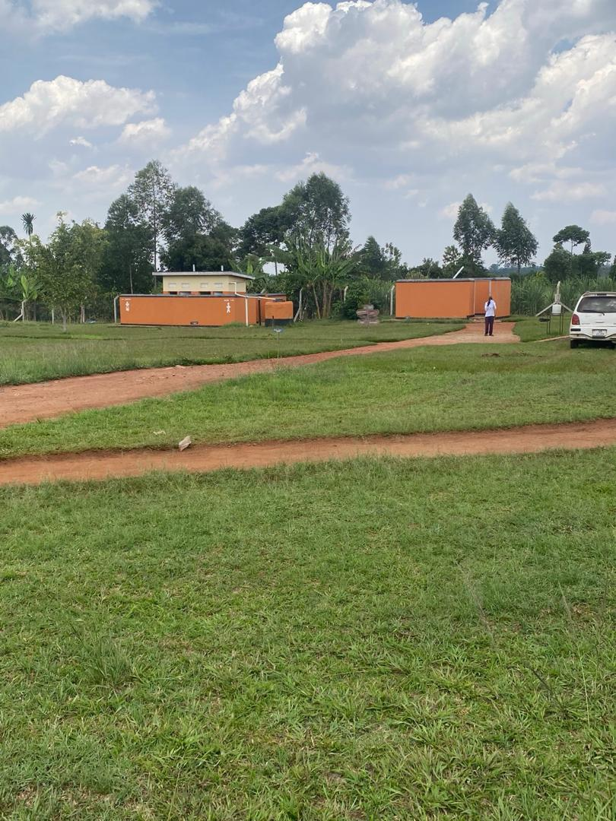
4 | A steel cupboard placed in the in-charge’s office | 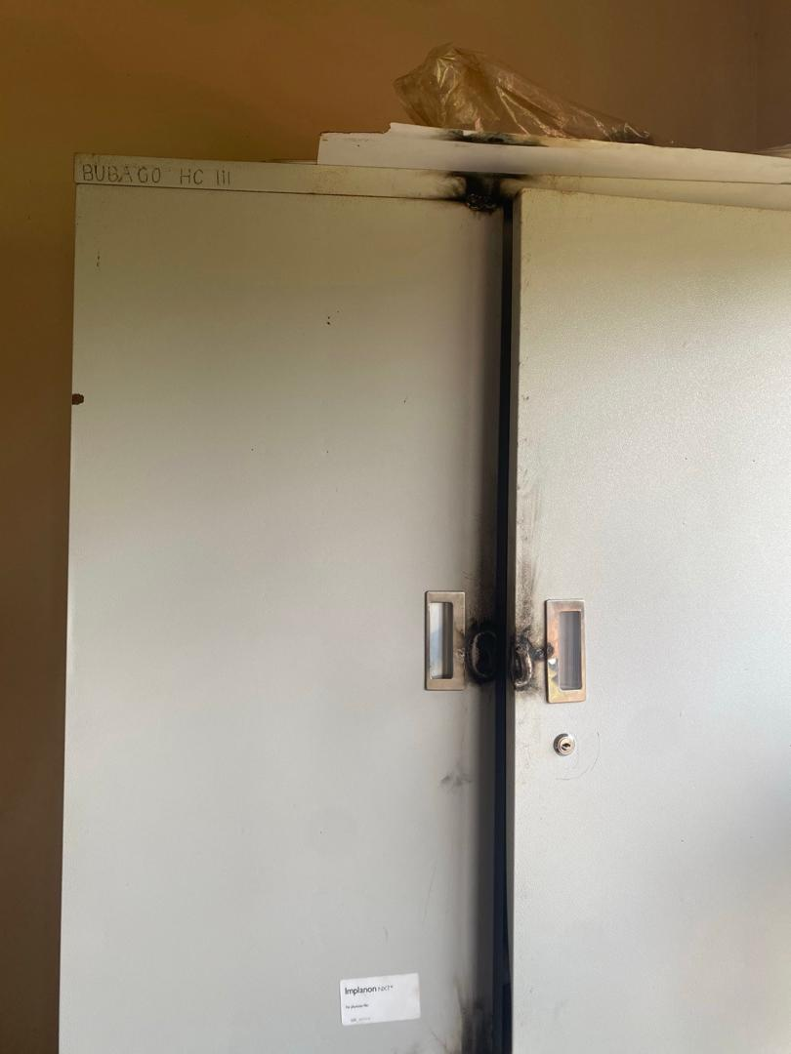
5 | An engraved examination couch | 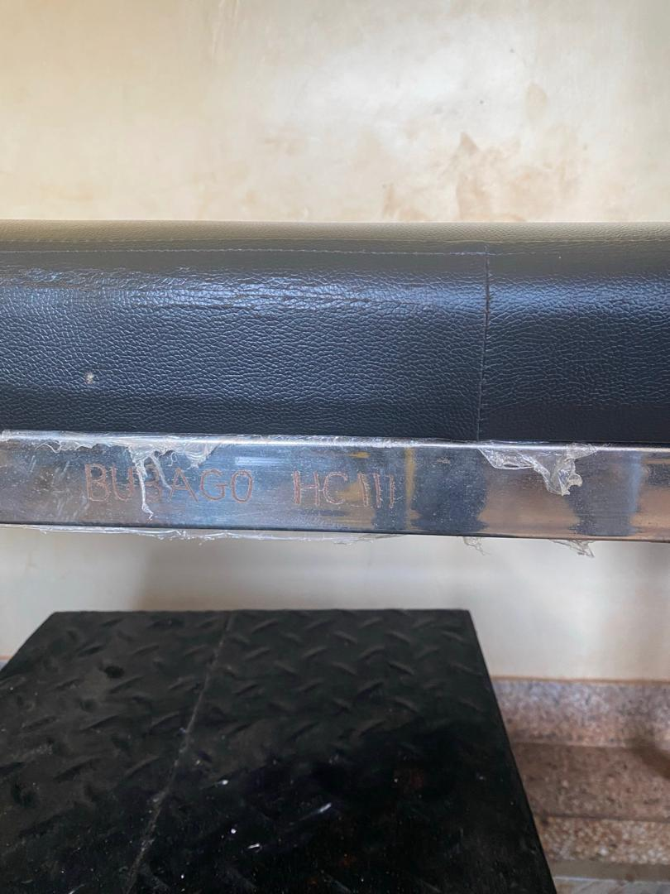
6 | A metallic instrument trolley under use in the OPD | 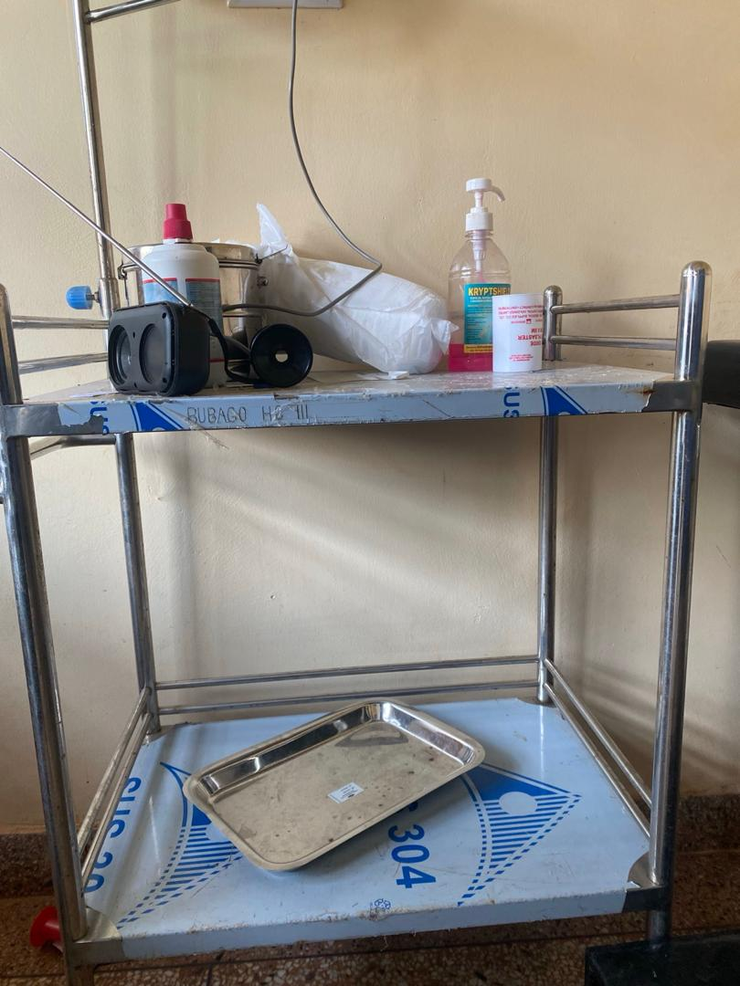
7 | An engraved wooden desk | 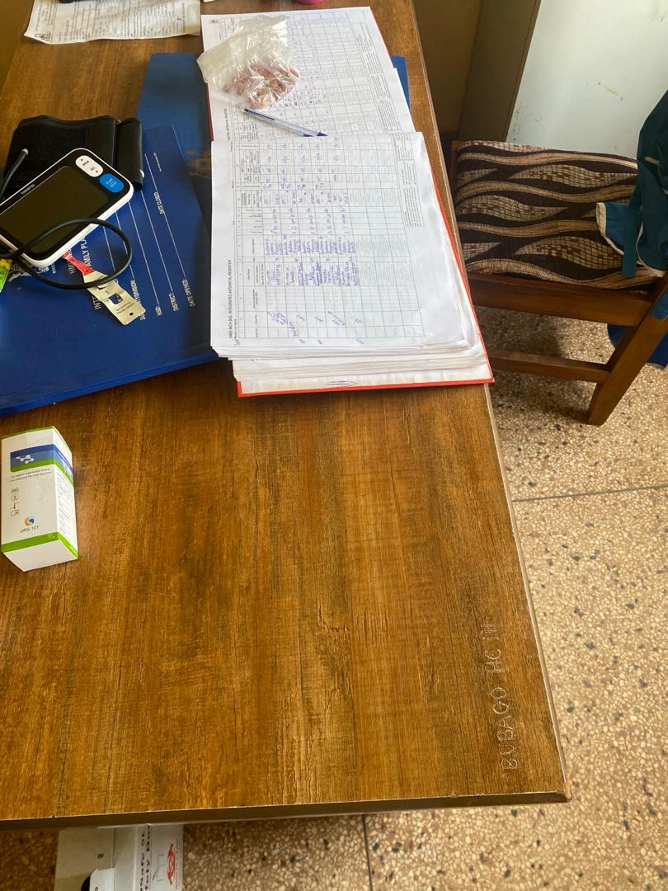
8 | Some of the medical equipment still in store. | 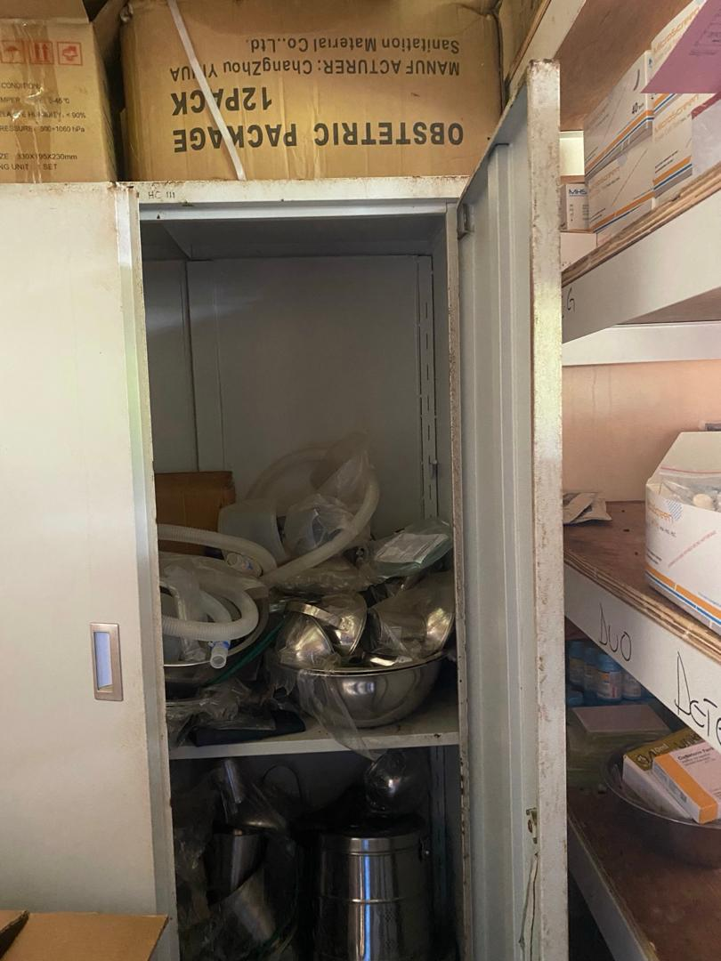
9 | The patient screen and duo flow oxygen concentrator in the labor suite | 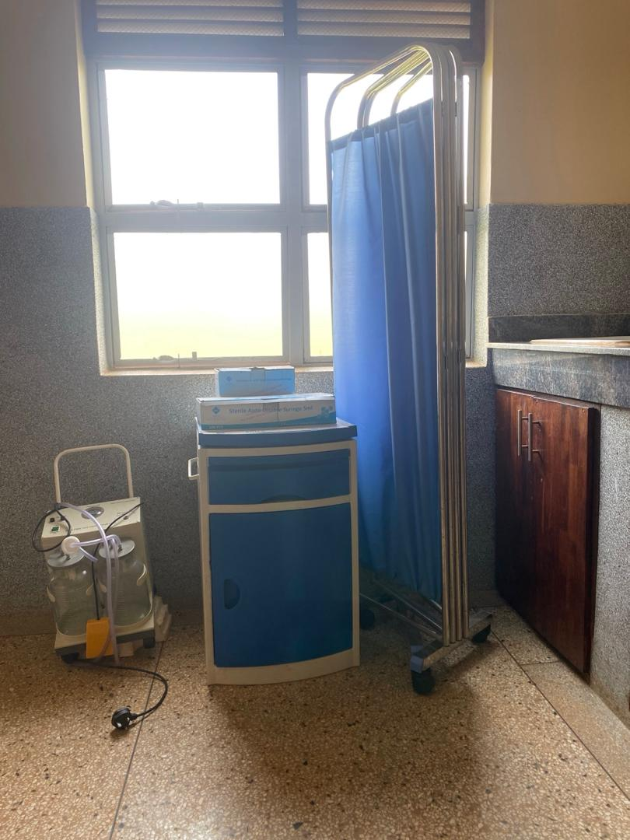
10 | The metallic cots with drip stands, 2-layered instrument trolley metallic and disinfectant bins. | 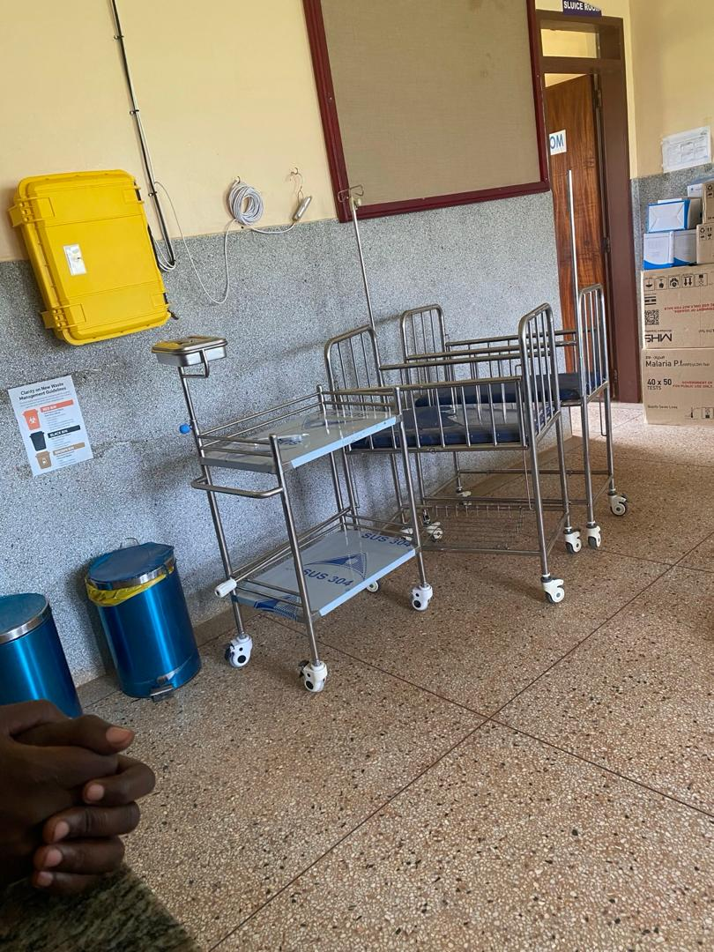
11 | Adult admission bed with black mattress, delivery bed with pink mattress and black LED examination lights in the labor suite. | 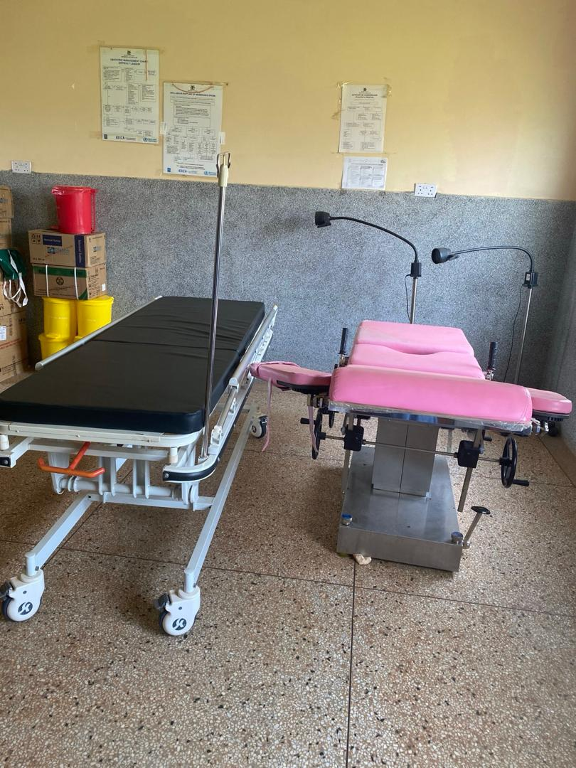
12 | A wall clock and a weighing scale for newborns. | 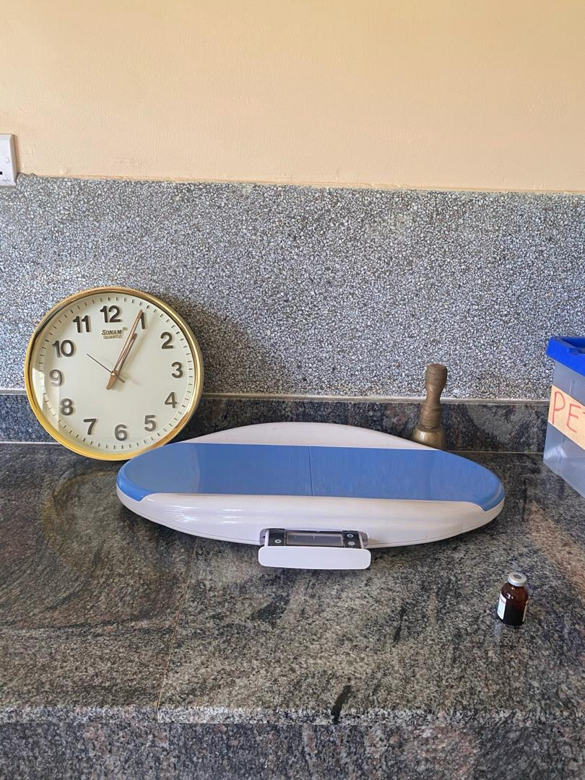
13 | A water facility and metallic bowl stand | 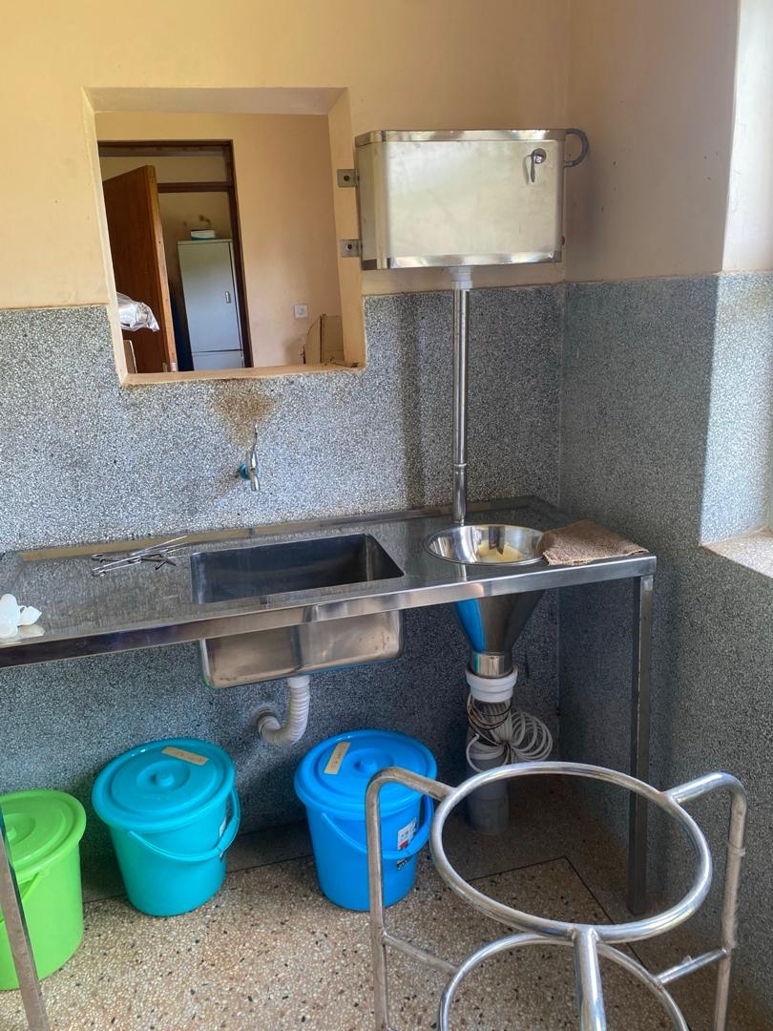
14 | The adult admission bed that is broken down. It’s placed in the OPD ward because the facility doesn’t have a store for non-functional equipment. | 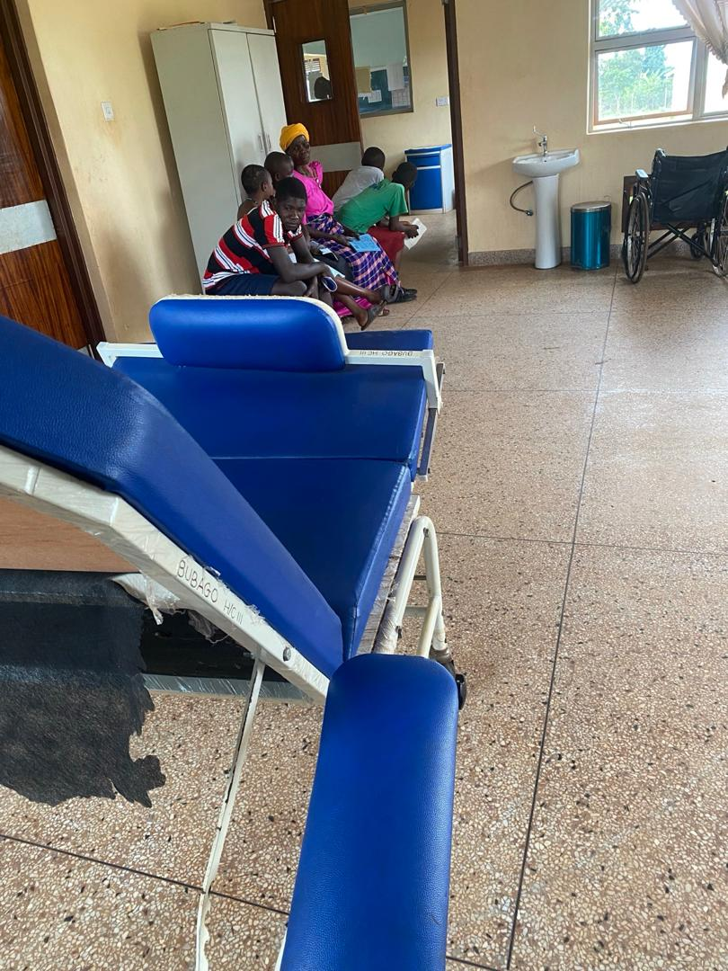
15 | Wheelchairs and bowl stand. The kick bowls in the picture are all rusty | 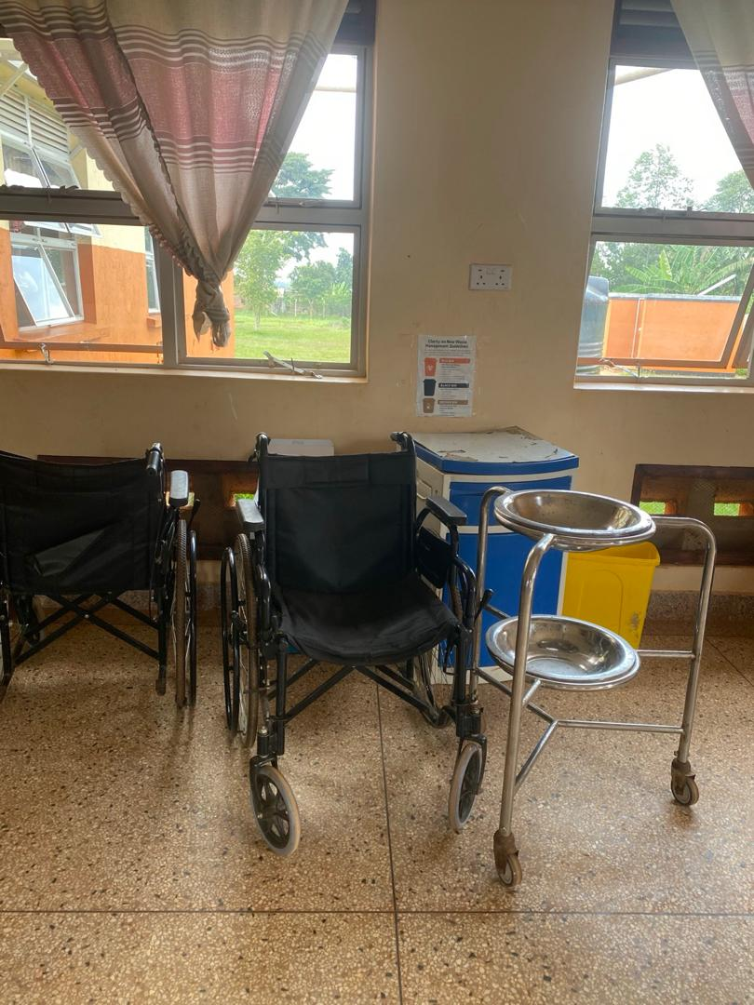
16 | A refrigerator and centrifuge all placed in the laboratory | 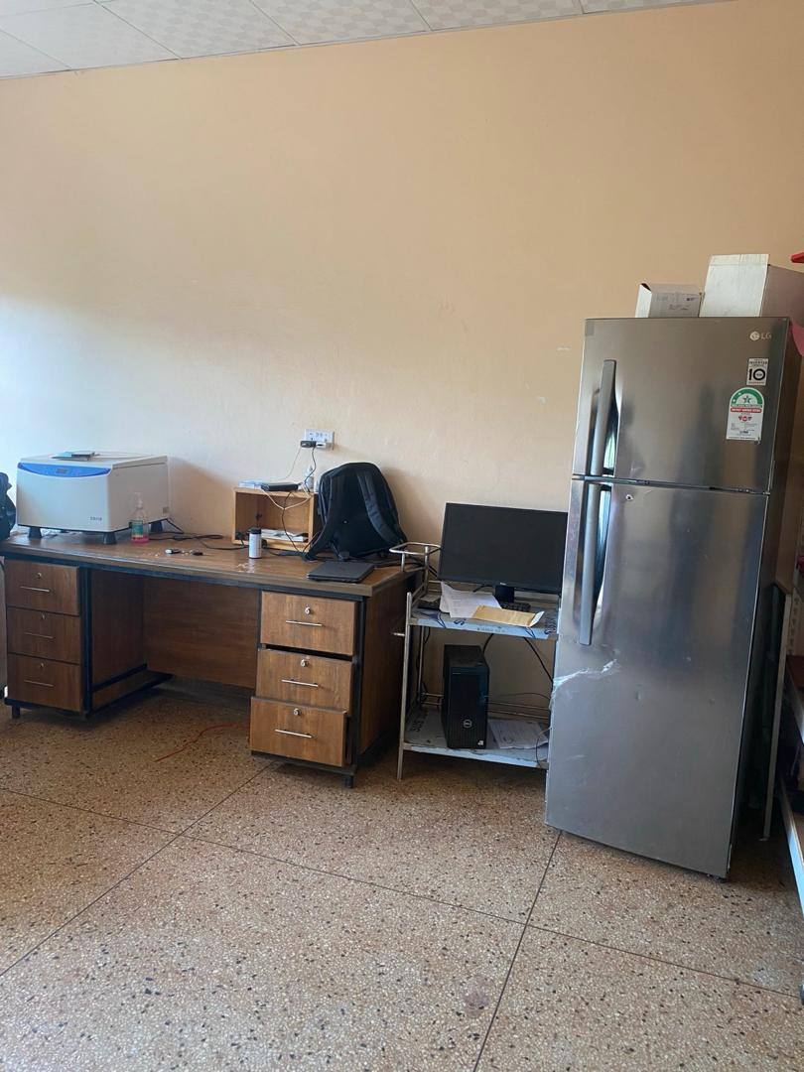
17 | Adult admission beds, drip stands in the adult ward | 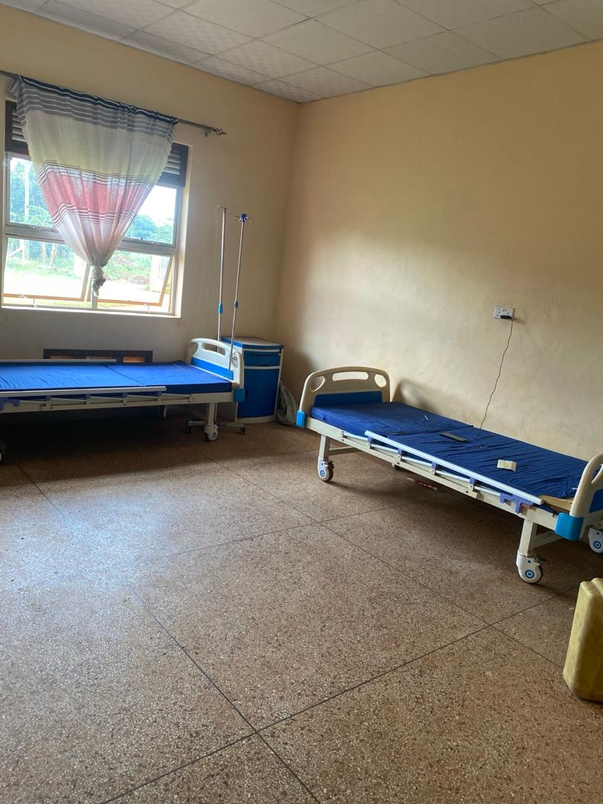
18 | Metallic pink Pediatric beds with small sized plastic cabinets. | 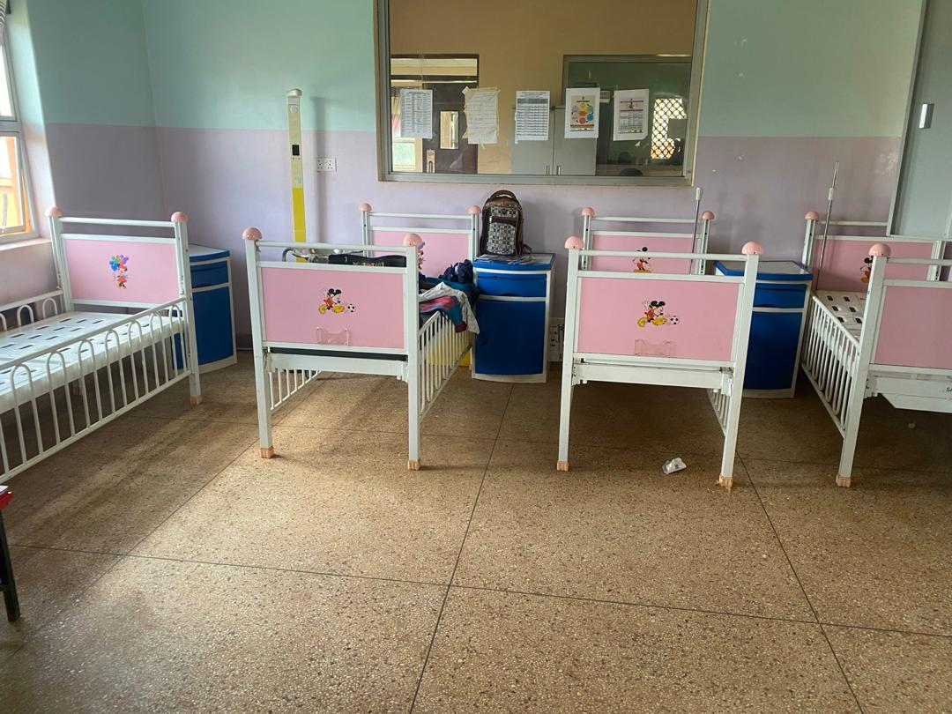
19 | Engraved pink Metallic pediatric bed. | 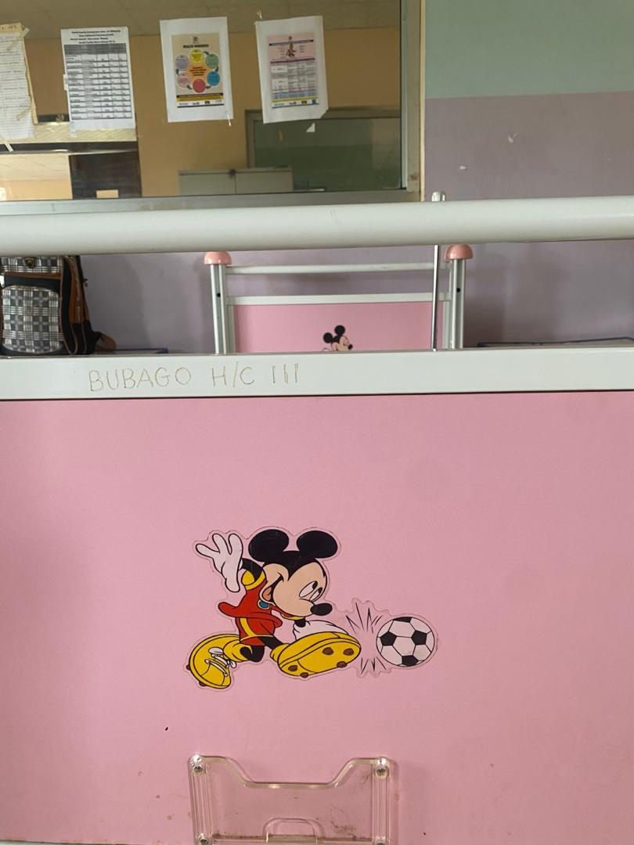
20 | Leather office chairs and a wooden desk in the OPD | 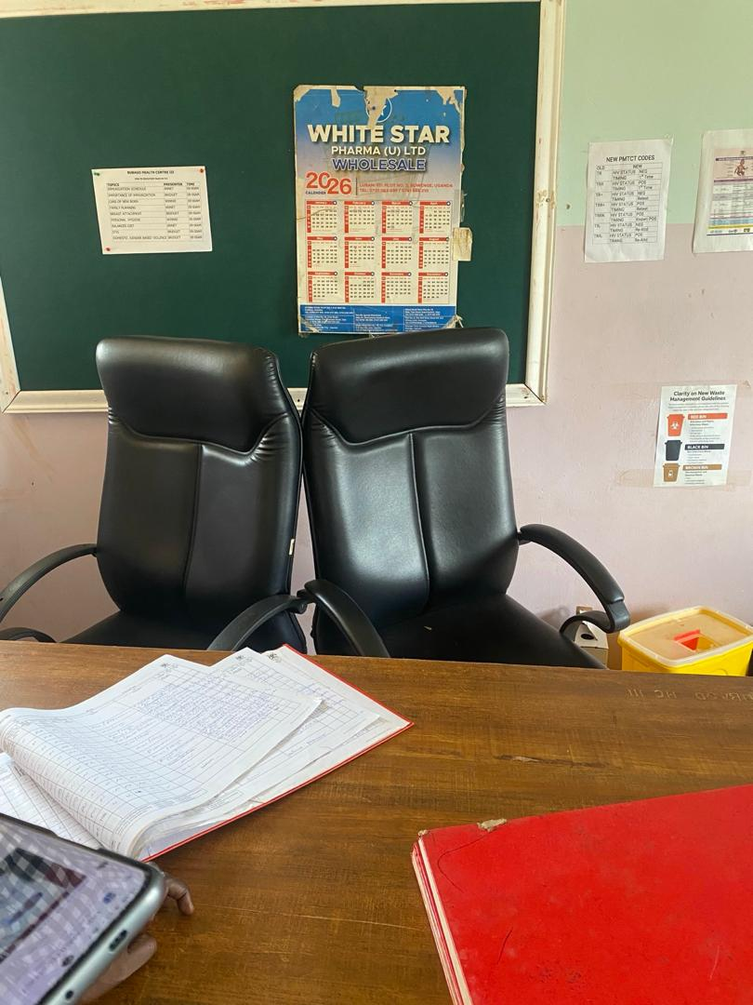
21 | The adult weighing scale that is already broken down | 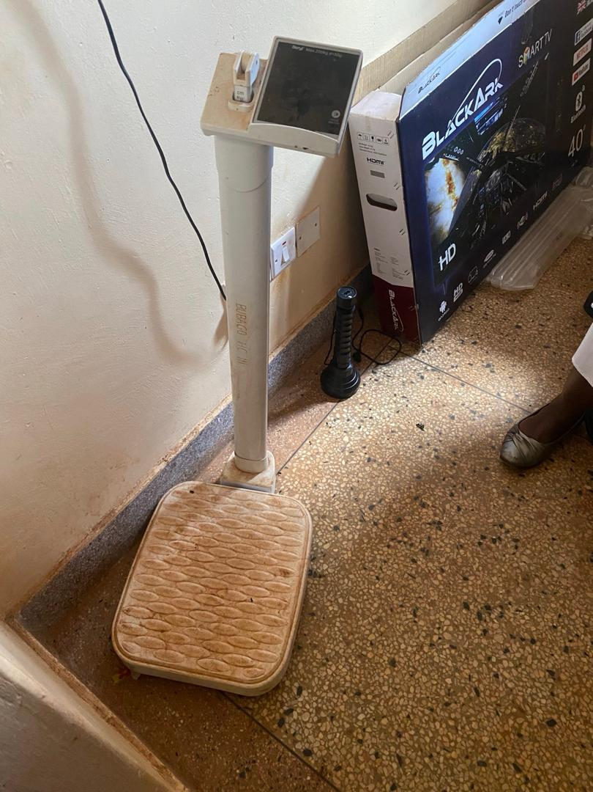
22 | The solar inverter that isn’t functioning. | 